BUSINESS 

U.S. sends billions back in tariff refunds — but not to NJ consumers

2-minute read
Daniel Munoz
NorthJersey.com
May 28, 2026, 4:26 a.m. ET
Companies began receiving their refunds in May from President Donald Trump’s now-invalid tariffs — but consumers should not expect to see any of the money return to their own pockets right away, if ever.
The refunds stem from the tariffs Trump imposed during the past year under the International Emergency Economic Powers Act, also called IEEPA, which the Supreme Court struck down in a February 2026 decision.
U.S. Customs and Border Protection rolled out the refund process, known as the Consolidated Administration and Processing of Entries, or CAPE.
Up to $166 billion in tariff collections could eventually be refunded, Reuters reported, and U.S. Customs and Border Protection had calculated over $35 billion in tariff refunds as of May 11.
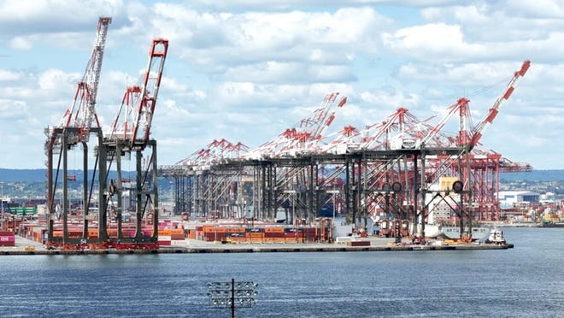

“Basically the refunds go to whoever paid the customs folks,” said Lawrence White, an economics professor at the NYU Stern School of Business in Manhattan.
“Almost always there’s an importer, a company — whether it’s Walmart doing it or Target doing it themselves, or a car company,” he continued. “And so it is they who get the refund.”
Contrary to Trump’s own words, experts say tariffs aren’t paid by the countries on which they’re levied. Rather, they’re a tax on foreign goods that is paid by businesses importing those materials and products.

Consumers 'got stuck with the bill'
Experts have said that companies are absorbing those costs, or are passing them on to consumers in the form of higher prices, or both.
“It isn’t fair,” Arthur Guarino, a finance professor at the Rutgers Business School in Newark, said of the tariff refunds. The consumers are "the ultimate ones that got stuck with the bill.”
Nearly 90% of tariff costs have been passed on to U.S. firms and consumers, according to a February report by the New York Federal Reserve.
“The consumer has to essentially ask the importer, ‘So you got your money back, when are you going to pay me my money back?’” NYU’s White said.

Class action suits against companies that got refunds
To that end, multiple class action lawsuits have been filed against companies that have received tariff refunds, including furniture retailer Ikea and sportswear and footwear company Nike.
Whether those plaintiffs have a case boils down to questions like, “What was the increase, was it really related to a tariff or some other factor?” said William McDevitt, a shareholder at the accounting firm WilkinGuttenPlan, who has advised several New Jersey companies on tariffs.
“Part of it could’ve been inflation,” McDevitt said. “Part of it could’ve been tariffs.”

Refunding through lower prices
Other companies have proactively given tariff refunds back to their customers, including UPS and FedEx, as well as Costco through lower prices to its members.
One possible route a company like Walmart or Target could take is to essentially reimburse customers for the tariffs they paid, White said.
“If I were Walmart, I would say… ‘show me the receipt that you bought this item, which we know was imported and this date, which we know at this point there was a tariff, and we will mail you a check,’” he said.
This article contains material from USA Today
Daniel Munoz covers business, consumer affairs, labor and the economy for NorthJersey.com and The Record.
Email: munozd@northjersey.com; Twitter:@danielmunoz100, Facebook and Instagram

