Mini-MBA™: Healthcare Management

CME/CE Accredited Internet Enduring Activity

Provided by
Rutgers Business School, Executive Education
and
Rutgers Health

Release Date: October 13, 2026
Expiration Date: January 26, 2027

Accreditation

 | In support of improving patient care, Rutgers Biomedical and Health Sciences is jointly accredited by the Accreditation Council for Continuing Medical Education (ACCME), the Accreditation Council for Pharmacy Education (ACPE), and the American Nurses Credentialing Center (ANCC), to provide continuing education for the healthcare team.

Physicians
Rutgers Biomedical and Health Sciences designates this enduring material for a maximum of 20 AMA PRA Category 1 Credits™. Physicians should claim only the credit commensurate with the extent of their participation in the activity.

Nurses
This activity is awarded 20 ANCC contact hours. Nurses should only claim those contact hours actually spent participating in the activity.

Physician Assistants
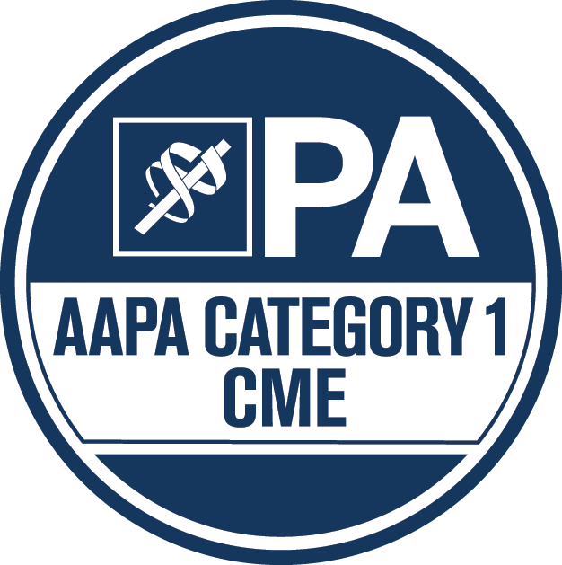 | Rutgers Biomedical and Health Sciences has been authorized by the American Academy of PAs (AAPA) to award AAPA Category 1 CME credit for activities planned in accordance with AAPA CME Criteria. This activity is designated for 20 AAPA Category 1 CME credits. Approval is valid until January 26, 2027. PAs should only claim credit commensurate with the extent of their participation.

Method of Participation

Participants must review all activity information, including the learning objectives, disclosure statements, and content. To receive CME/CE credit for participation, participants must complete the Final Exam and Capstone Project (achieving an average grade of 70% or greater to pass the course), and the course evaluation. CE certificates will be emailed to participants approximately 30 days after completing the course as designed.

Peer Review

In order to help ensure content objectivity, independence, and fair balance, and to ensure that the content is aligned with the interest of the public, this content has been reviewed by a non-conflicted, qualified reviewer. This activity was peer-reviewed for relevance, accuracy of content, and balance of presentation by:

Gary Branning, MBA, President, Managed Market Resources, Mount Olive, NJ

Disclosure Declarations

In accordance with the disclosure policies of RBHS and to conform with Joint Accreditation requirements and FDA guidelines, individuals in a position to control the content of this educational activity are required to disclose to the activity participants: 1) the existence of any relevant financial relationship with ineligible company, i.e., a company whose primary business is producing, marketing, re-selling, or distributing healthcare products used by, or on patients, within the past 24 months; and 2) the identification of a commercial product/device that is unlabeled for use or an investigational use of a product/device not yet approved.

Faculty

The following faculty have no relevant financial relationships with ineligible companies to disclose.

Joseph N. Agresta, MBA
Gary Branning, MBA
Céu Cirne-Neves, MPA
Xin (David) Ding, PhD, MS
Jane C. Kaye, MBA
Rachel Kelly
Michael S. Lewis, MBA
John M. Longo, PhD, CFA
John P. Murdoch II, Esq
Philip Patrick, MBA

Planners

The following planners have no relevant financial relationships with ineligible companies to disclose.

Gary Branning, MBA, President, Managed Market Resources
Jennie Fine, Associate Director, Executive Education, Rutgers Business School
Patrick Dwyer, Director, Continuing Medical Education, Center for Continuing and Outreach Education, Rutgers Biomedical and Health Sciences

Off-Label/Investigational Use

This activity does not contain information on commercial products/devices that are unlabeled for use or investigational uses of products not yet approved.

Disclaimer
The views expressed in this activity are those of the faculty. It should not be inferred or assumed that they are expressing the views of any other manufacturer of pharmaceuticals or medical devices, or Rutgers.

Copyright © 2026-2027. Rutgers, The State University. All rights reserved including translation into other languages. No part of this activity may be reproduced or transmitted in any form or by any means, electronic or mechanical, including photocopying, recording, or any information storage and retrieval systems, without permission in writing from Rutgers.

Please direct technical questions to Jennie Fine at 848-445-9418 / jfine@business.rutgers.edu

Please direct CE related questions or concerns to Patrick Dwyer at 973-972-8377 / patrick.dwyer@rutgers.edu

To review Rutgers’ continuing education privacy policy, visit

https://ccoe.rbhs.rutgers.edu/contact/ccoe-privacy-policy/

